Exhibition proposal for the ‘constant velocity’
Name
Institution

Abstract
Students are exposed to various learning opportunities through the use of the visual art and the literature materials. The literature and the visual arts set are meant to explain the integration of constant velocity. The artist interest is to explain to the audience on his investigation about the energy and space. The exhibition target at helping the audience to conceptualize on the correlation between power and space. Also, the exhibition has a way of explaining to the audience how the energy in an area is abundant. The audience ability more understanding the constant velocity is enhanced, and the students' negative attitude towards physics and physically related courses is related. Various posters with the space drawings will be used to improve ensuring that the audience gets the best. Postcards, postage and exhibition brochures will also be used to enhance the knowledge of the exhibition to the audience. All these materials will be used and show in the Walsh Gallery. These poster drawings will be downloaded from the internet and printed. Printing compared to physical drawing will help in saving the time, and it is cheap to print than physical rendering. Furthermore, this will enrich students with more knowledge on the ways the energy in space can be used and various extended application of the space energy.
The various posters and other pictorial drawings will be in line with the topic being tackled. In the exhibition, there is a panel. The panel will be guiding the exhibition and helping in the presentation of the themes to the gallery. The relevance of the exhibition will have been developed in the minds of the audience by the slave narrative as the narrative continues.
The aim of this exhibition will be to portray the energy and the space interaction. The audience will also get knowledge on the ways of tapping this power from the environment.

Exhibition narratives
The artist Ryan Roa's description, constant velocity is meant to convey a message of his investigation about energy and space to the audience. The installation of the site responsiveness is made of black rubber bungee cords commonly referred to as wedges, pyramid, and cones in simpler term. The artist stretches the cables in the various configurations away from the walls, ceilings, and floors causing tension that is transmitted through the rubber material. The taut rubber bungees have straight lines that combine creating series of overlapping forms that are meant to be seen from varying vantage points and therefore produces series of moiré patterns as viewers navigate Roa's set of Space Drawing. Space is left between the arrangements. This is because Roa presents viewers with elements that can be read as individual sculptures or cumulatively, as an installation. The forms to be used by every individual is sympathetically arranged in the gallery to complement and offer challenges of existing architectural features.
Drawing with the bungees in three-dimensional space, Roa references forms derived from the ancient and classical architecture. Utilized since the advent of building construction, the wedge, pyramid, and cone have been used in the temple, stupas, mastabas and other iconic structures to displace gravity, hence creating equilibrium between opposing expansion and compression forces. The stretched bungee cords create similarly offset opposing forces, although their functional associations lack the grandeur of the materials employed in the construction of the monolithic buildings. Roa simultaneously undermines relationships to historical architecture by using dimensions that more closely reference human scale. In doing so, he calls to attention the experience of movement through surroundings, as well as the viewers' relationship to space and objects within it.
After installation, the bungees is hanged in a state of suspended energy, capturing the artist's exertions to wrestle the elastic lines into place. Bungees are pushed to the limit of their capacity and pulled tightly from opposing points within the gallery. The bungees concomitantly push the gallery architecture to its limits and the artist adjusts the tension of each piece to accommodate architectural constraints. Challenging material and space, Roa finds stasis in the area where compression and tension are equal, or in constant velocity, creating a precarious state where energy is temporarily stored in the bungees.
The impending movement sense echoes the functionality of the bungees. Ordinarily used to secure objects, they are often used to avoid risk or harm by constraint. Their black tone and austere metal hardware hooks reinforce cultural associations with peril. Stretched throughout the gallery, the rubber materials have an inherently palpable capacity to spring reflexively from their affixed points, paradoxically, at odds with their purpose. This sense of danger is echoed in the warning inconspicuously stamped on each bungee cautioning users of load capacity and possible failure which may result in injury.
The bungees evoked movement vis- à- vis their elasticity and dynamic installation with multifarious rhythms and vectors and poised between motion and a state of rest. Roa arranges the forms to construct passages and obstructions, obliging viewers to respond by negotiating the overlapping shapes and line. Each enactment of the Space Drawings is but one of the infinite experiences and relationships formed by moving through and around the work.
The conflation of the potential energy stored in the bungees against the kinetic energy of the artist's and visitors' enacting of the work is the main narrative impulse of the exhibition. However, the relationship between object, space, and individual is equally paramount to Roa's concerns. The artist forms series of a complex by reading subtexts of the work, yet understated associations between iconic structures, geometry, and physics presented in a limited variety of materials and formal lexicons.
Compositionally, "Constant Velocity" consists of four primary recurring structures arranged in six to eight vignettes. Space Drawing 26 approximates a deconstructed, upside-down pyramid from a frontal vantage point. When seen from the side, the pyramid shape collapses into a skewed triangle bisected by a high line through its center. The tension in the bungees is echoed in the precarious form resting on point. Space Drawing 27 is comprised of a pair, or arrangements of couples, of elongated isosceles pyramids with bases, stretched between planes (walls, floor, and ceiling.) The pyramids meet mid-air at their points, joined by metal hardware. The bungees line the vertical edges of each pyramid, the termini affixed to strong eye hooks. In Space Drawing 28 Roa outlines not just the contours of the shape, but also the sides and interior, presenting another dynamic form that implies more density than the two previous drawings. This more significant, skewed pyramidal form is again investigated by the artist in Space Drawing 30, which is comprised of two, skewed wedges sharing the same base, but diverging into two separate points set on perpendicular planes. Other variants of these Space Drawings may be included as necessitated by the architecture and space of the gallery.
This gallery installation is to be accompanied by a large-scale Space Drawing in the atrium of the Berry Center, with many bungees attached to three points in the ceiling, each terminating on the second-floor balcony wall. This will form three converging conical shapes with variable elements. This variant is conceived especially for this site, energizing public space on all floors of the Berry Center. Vantage points from the first floor looking up, or the second floor looking either up or down, offer dramatic perspectives that are unachievable in the gallery. Another important variant will be the longer runs of interlocking bungee cords which will be quite visible and structurally different regarding tension than those of the smaller Space Drawings 26, 27, 28 and 30. Subtle visible movement in the cords hint at the stored energy waiting to be released as these more slack rubber lines will respond to the kinetic energy transmitted throughout the active Berry Center.
Lastly, video documentation of the artist installing the drawings will be played on a loop on the second floor to both contextualize the public installation as well as promote the exhibition outside of the gallery proper. Alternatively, there can be a podcast that visitors may be directed to by use of a QR code on a wall label or object label. The URL can also be embedded within the gallery's website to provide remote access to the video. While not explicitly part of the installation, the accompanying video documentation will demonstrate the physicality required to make the Space Drawings and the transformation of Roa's actions into stored energy held by the bungees until they are released.
Programs
The exhibition will be programmed by the artist that will be both directed at both students and the general public. The talk will be facilitated by the Curator Jeanne Brasile.
The gallery management and all another aspect of curating will be discussed by the curator. The curator will also discuss the exhibition development with the students studying the fine art, art history, design or enrolled in gallery management class.
Curator will also ensure efficient working with the faculty to ensure correct interpretation of exhibition in the context which facilitates varying curricula.
Target audience
The audience of the exhibition will be in the gallery and others will be far in various parts of the world. All these viewers will be having access to the presentation. The public relation will significantly help to ensure that those who are not in the gallery can access the happening in the exhibition.
The principal target groups or audience of the exhibition are:
- Constituency of community members
- Faculty and staff members
- Students particularly the ones studying fine art and art history.
Artist and curator both have the audience in Essex, Passaic and Hudson counties in New Jersey, Brooklyn, and Manhattan.
Public relations
The exhibition will be having members from various parts of the world who will not be physically available for the exhibition. Such members will access our content due to the vigorous public relations that will be conducted. The public relations will be done through various ways which include direct emails, direct post cards mailing, social media and press releases that are distributed to the individual, art blogs, specific art critics, curators, and patrons.
Design
Production of the modest tri fold catalog with perfect binding, a more significant number of images and various essays whose source is the curator and also from scholars and referencing the Roa's work.
Video accompaniment will be there to ensure additional context in which to interpret the work that could be tailored meeting the curricula expectation.
The professor will be encouraged to attend the exhibition to include it in the coursework.
The artist talk will be recorded on video as a method of documentation of the exhibition. The video can be linked to online video streaming websites such as YouTube or Vimeo.

Budget“Constant
DESCRIPTION |  |  | ITEMIZATION |  |  | SUBTOTAL |  | TOTAL
Gallery Preparation
Installation Hardware |  | O-Rings, Eyehooks, Anchors, etc. |  |  | $150.00 |  |  | $150.00
Gallery Prep |  | Spackle, Sand Paper, etc. |  |  | $25.00 |  |  | $25.00
 |  |  |  |  | Gallery Preparation
 |  |  |  |  | SUBTOTAL:
 |  |  |  |  |  |  |  |  |  |  |  | $175.00
Printed Material
Postcards |  | 5000 |  |  | $160.00 |  |  | $160.00
Postage |  | .33 x 2000 |  |  | $660.00 |  |  | $820.00
Posters |  | .50 x 50 |  |  | $25.00 |  |  | $845.00
Exhibition Brochure |  | 500 pieces |  |  | $305.00 |  |  | $1150.00
Text Panel |  | 1 |  |  | $300.00 |  |  | $1450.00
Vinyl Letters (title) |  | 1 |  |  | $100.00 |  |  | $1550.00
 |  |  |  |  | Printed Material SUBTOTAL:
$1550.
00
Personnel
Artist Honoraria |  | Artist Talk + travel, time, expenses |  |  | $600.00 |  |  | $600.00
Curator Honoraria |  | Travel, time, expenses |  |  | $600.00 |  |  | $1200.00
 |  |  |  |  |  | Personnel
 |  |  |  |  | SUBTOTAL: |  |  |  |  |  | $1200.  00
Reception Food/Drink
Food – Reception |  | 3 platters |  |  | $300.00 |  |  | $300.00
Wine - Reception |  | 75 x 3 |  |  | $225.00 |  |  | $525.00
Food/Drink for
 |  |  |  |  |  |  |  | $675.00
Attendees Artist Talk |  |  |  |  | $150.00
 |  |  |  |  | Reception Food/Drink
 |  |  |  |  | SUBTOTAL:
$675.
00
 |  |  |  |  | TOTAL EXHIBITION
 |  |  |  |  | BUDGET: |  |  | $3600.00

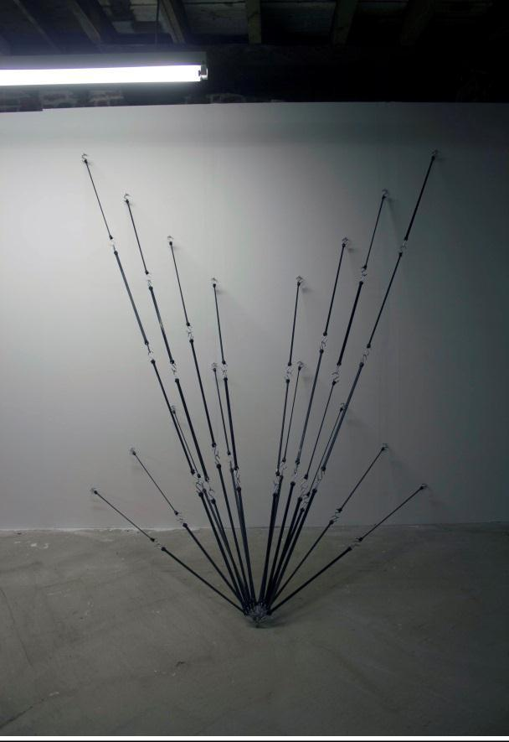
Floor plan
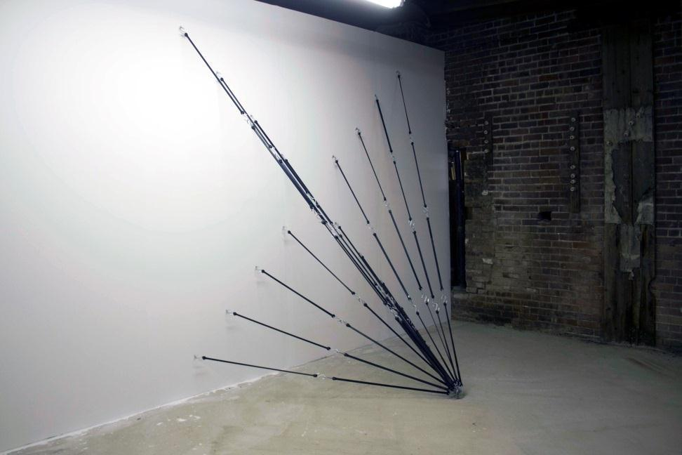

Space Drawing #26 (alternate view)

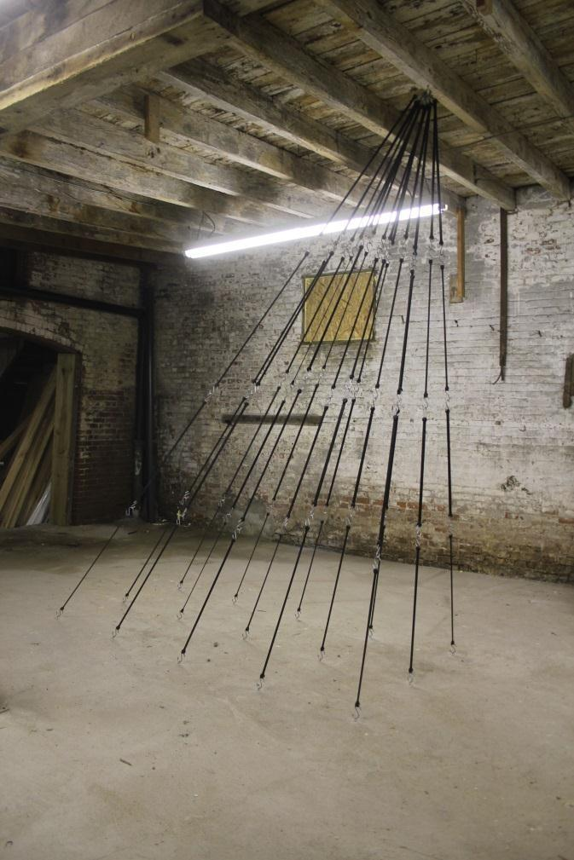
Space Drawing #26, rubber bungee cords and hardware,
9’ x 8’ x 5’, 2012
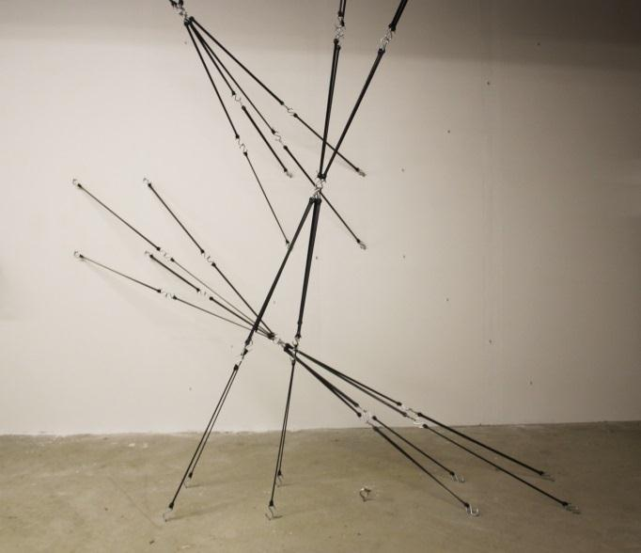

Space Drawing #27, rubber bungee cords and hardware, Space Drawing #28, rubber bungee cords and hardware,
dimensions variable, 2012 96” x 48” x height of ceiling, 2012

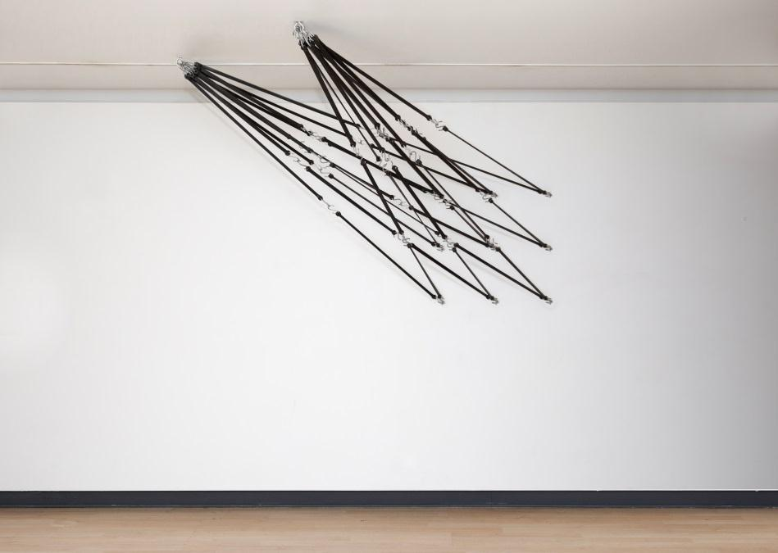
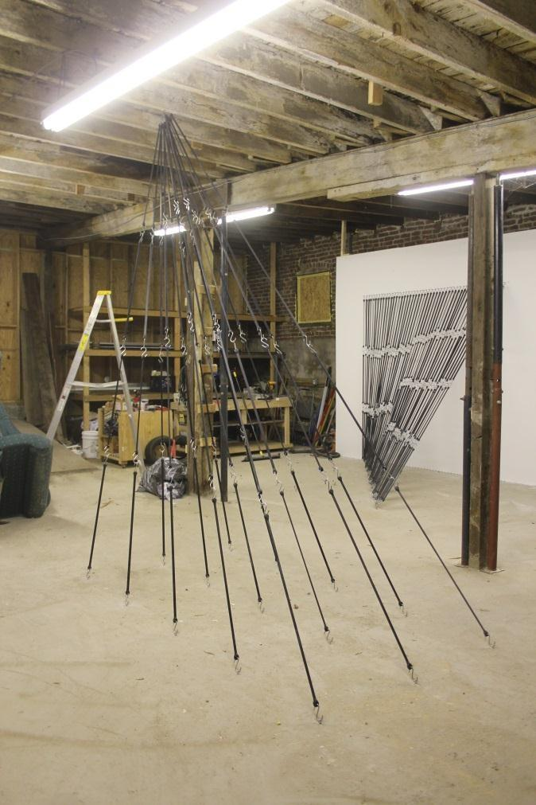

Space Drawing #30 rubber bungee cords and
hardware, height of the ceiling x 7' x 5', 2013

Space Drawing #28 (alternate view)
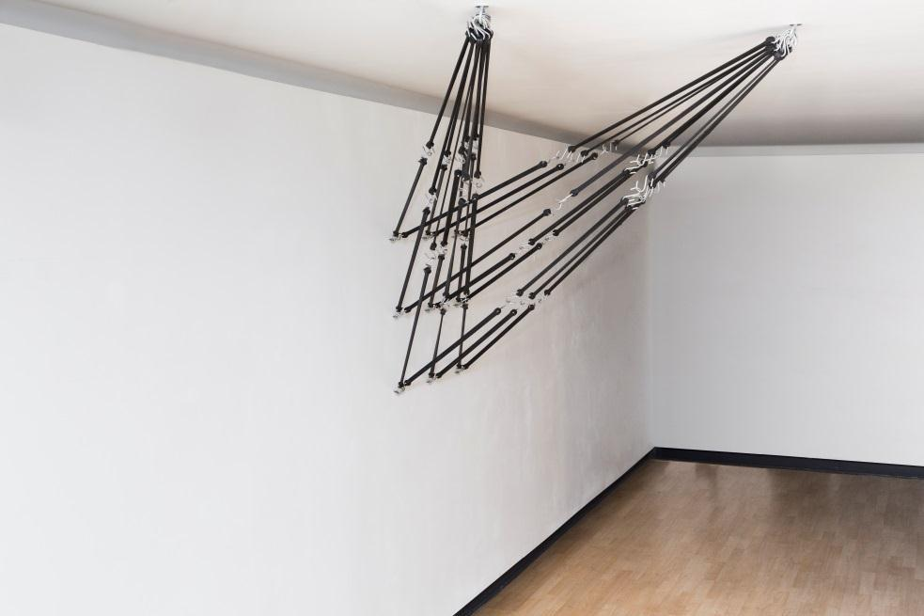
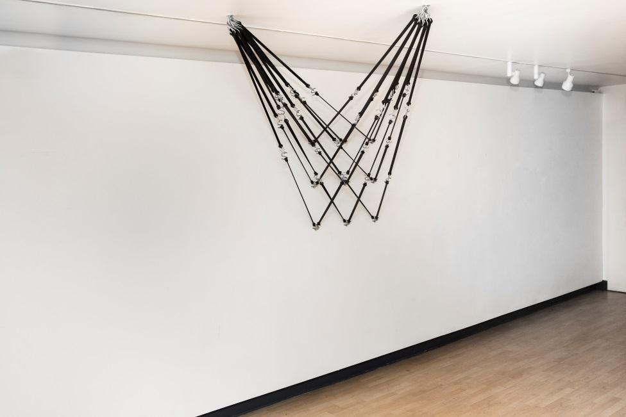

Space Drawing #30 (alternate view) Space Drawing #30 (alternate view)

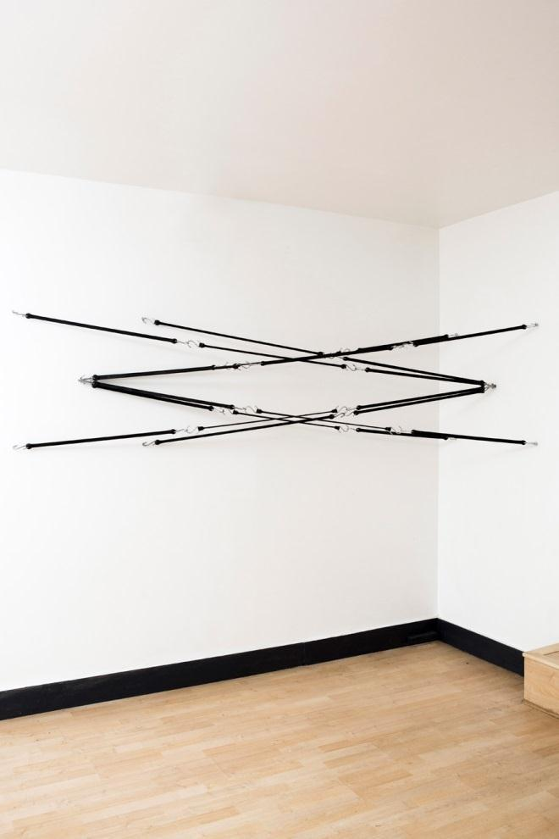
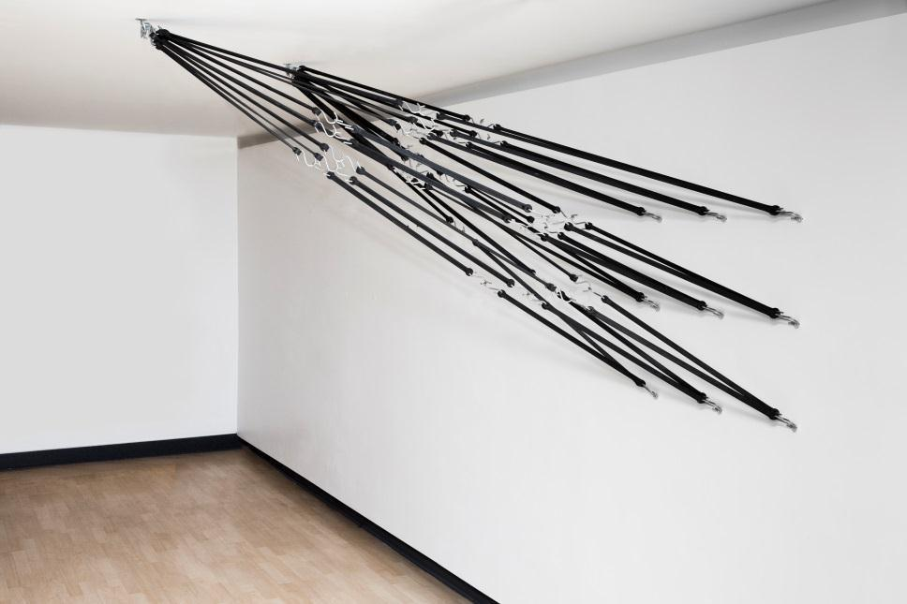

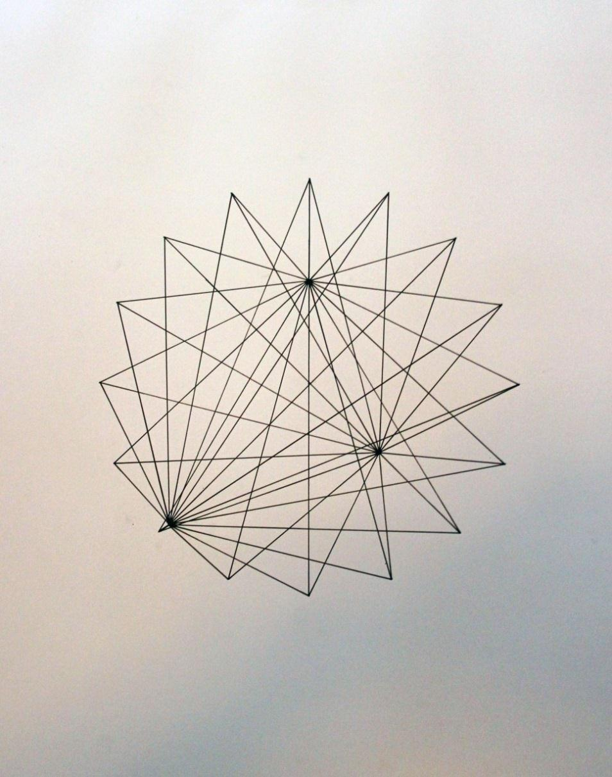
Space Drawing #30 (alternate view)

Space Drawing #29 Rubber bungee cords and hardware, dimensions variable, 2013

Space Drawing (study for proposed installation in (omitted) Center atrium)
rubber bungee cords and hardware, dimensions variable, 2013

Exhibition timeline
The tasks are carried out chronologically as follows:
- Idea development
- Concept writing
- Target audience identification
- Working title identification
- Allocating tasks
- Collection material audit
- Non-collection material audit and development of budget
- Research
- Design layout
- Catalogue design
- Plan opening
- Install exhibition
- Opening and conducting programs
- Maintenance
- Demounting

Key staff
- Curator – the curator works as the overseer of the exhibition
Roles
- Contacting the artist and working with the artist to ensure collection of the resources to be used.
- Designing the structure of the exhibit
- Delegating construction and cleaning work to the staff members
- Ensure there is lighting, sound and views area
- Keeping exhibit on schedule
- Ensuring that the exhibition is under its budget
- Facilitating storage of the various resources such as artefact after exhibition
- Collection manager – their responsibility is basically managing the collections.
- Cooperates with the curator and other staff members to ensure exhibition work is done
- Retrieves the various collections from conservation upon curator’s request.
- Ensures establishment and standards of collections care, up to when to the display and back to conservation.
- Gives expenditure projection on the collections
- Facilitates cleaning of the various artefacts used and ensuring their condition is known.
- Gallery manager- basically these are the for the ensuring directions of the viewers and directing and giving information to those buying several artefacts
- Working with the artist and giving artist information about the forthcoming ,exhibition
- Ensuring visitors get information about the exhibition
- Managing gallery store and monitoring whatever goes out or in the store.
- He also deals with framer

Curator’s resume
Jeanne Brassile
Contacts
Professional Summary
I am an experienced curator with arts education, public arts programming and public policy knowledge. I have skills on public relations have many contacts to get in the local media to get them into the exhibition. I also possess knowledge in grant writing. Have superior speaking skills and enough personal service experience and therefore can spend much time with guests in exhibitions.
Work Experience

Education and Training

Skills
- Have excellent communication skills
- a team worker and can work amicably with other staff members
- I’m familiar with project management software
- Have knowledge of working with the digital cameras
- Possess excellent leadership skills
Hobbies and Interests
- I love art, it’s a work from within not just being a curator.
- I am a fun of watching shows and exhibitions

